**KL UNIVERSITY**

**DEPARTMENT OF COMPUTER SCIENCE ENGINEERING**

# A Project Based Skill Report On

# MALARIA DETECTION

SUBMITTED BY:

|  |  |
| --- | --- |
| **STUDENT ID** | **STUDENT NAME** |
| 190030352 | Dagani. Anudeepthi |
| 190030386 | Devathi Uma Venkata Naga Kowshik |
| 190030464 | Gandham Teja |

**UNDER THE ESTEEMED GUIDANCE OF**

**Dr. S Sagar Imambi**

**ASSOCIATE PROFESSOR**



## KL UNIVERSITY

**Green fields, Vaddeswaram – 522 502 Guntur Dt., AP,India.**

**Department Of Computer Sciences Engineering**



## CERTIFICATE

This is to certify that the project-based laboratory report entitled Bibliophile submitted by D.Anudeepthi, D. UVN Kowshik, G. Teja bearing Regd. No. 190030352, 190030386 and 190030464 to the **Department of Computer Sciences Engineering, KL University** in partial fulfillment of the requirements for the completion of a project in “Deep learning” course in III B.Tech II Semester, is a bonfire record of the work carried out by him/her under my supervision during the academic year 2021-22.

PROJECT SUPERVISOR HEAD OF THE DEPARTMENT

Dr. S Sagar Imambi Dr. Hari Kiran Vege

## ACKNOWLEDGMENTS

It is great pleasure for me to express my gratitude to our honorable President **Sri. Koneru Satyanarayana**, for giving the opportunity and platform with facilities in accomplishing the project based laboratory report.

I express sincere gratitude to our Coordinator and HOD-CSE **Dr. Hari Kiran Vege** for his leadership and constant motivation provided in successful completion of our academic semester. I record it as my privilege to deeply thank for providing us the efficient faculty and facilities to make our ideas into reality.

I express my sincere thanks to our project supervisor Dr. S Sagar Imambi for her novel association of ideas, encouragement, appreciation and intellectual zeal which motivated us to venture this project successfully.

Finally, it is pleased to acknowledge the indebtedness to all those who devoted themselves directly or indirectly to make this project report success.

|  |  |
| --- | --- |
| 190030352 | Dagani. Anudeepthi |
| 190030386 | Devathi Uma Venkata Naga Kowshik |
| 190030464 | Gandham Teja |

**INDEX**

1. **Introduction of the Project 1**
2. **Abstract and problem statement 2**
3. **Software Requirements 3**
4. **Hardware Requirements 3**
5. **Requirement Analysis 4**
6. **Finalizing Requirements 4**
7. **Model Used 6**
8. **Implementation 15**

**10) Implementation Output Screenshots 37**

**11) Result 54**

**12) Conclusion 54**

### INTRODUCTION TO MALARIA DETECTION

Malaria is a life-threatening disease. It’s typically transmitted through the bite of an infected anopheles mosquito. Infected mosquitoes carry the plasmodium parasite. When this mosquito bites you, the parasite is released into your bloodstream. It is considered as an endemic in many parts of the world.

Malaria detection is performed by examining a drop of the patient’s blood, spread out as a “blood smear” (red blood cell) on a microscope slide. This blog focuses on improving malaria detection from such patches segmented from the microscopic images of blood smears by introducing a deep convolutional neural network. Compared to the traditional methods that use tedious hand engineering feature extraction, the proposed method uses deep learning in an end-to-end arrangement that performs both feature extraction and classification directly from the raw segmented patches of the red blood smears.

### Risk Factor:

Malaria is commonly associated with poverty and has a major negative effect on economic development. In Africa, it is estimated to result in losses of US$12 billion a year due to increased healthcare costs, lost ability to work, and negative effects on tourism.

### Symptoms of Malaria

A malaria infection is generally characterized by the following signs and symptoms:

* Fever
* Chills
* Headache
* Nausea and vomiting
* Muscle pain and fatigue

Other signs and symptoms may include:

* Sweating
* Chest or abdominal pain
* Cough

### How is Malaria diagnosed by pathologists?

Typically Malaria is diagnosed by microscopic examination of blood cells under the supervision of a pathologist. Red blood cells are examined using a microscope using blood films. The pathologist tries to find evidence of Malaria using past domain knowledge. Typically, when a cell is infected with Malaria one can see distorted cell shapes which are also accompanied by certain blunt spots in the cell.

**ABSTRACT**

* Malaria is a significant burden on our healthcare system and it is the major cause of death in many developing countries. The disease caused by a parasite that commonly infects a certain type of mosquito which feeds on humans. The traditional microscopy technique has a few weaknesses which incorporate time utilization and reproducibility of the results. Early testing is necessary to detect malaria and save lives.
* This project deals with the automatic identification of malaria-infected cells using deep learning methods. Deep learning methods have the advantage of being able to automatically learn the features from the input data, thereby requiring minimal inputs from human experts for automated malaria diagnosis.
* The main aim of this malaria detection system is to address the challenges in the existing system by automating the process of malaria detection using Deep learning and image processing.

### PROBLEM STATEMENT

For malaria as well as other microbial infections, manual inspection of thick and thin blood smears by trained microscopists remains the gold standard for parasite detection and stage determination because of its low reagent and instrument cost and high flexibility. Despite manual inspection being extremely low throughput and susceptible to human bias, automatic counting software remains largely unused because of the wide range of variations in bright field microscopy images. However, a robust automatic counting and cell classification solution would provide enormous benefits due to faster and more accurate quantitative results without human variability; researchers and medical professionals could better characterize stage-specific drug targets and better quantify patient reactions to drugs.

### Steps to solve the problem:-

1. Loading the data.
2. Exploratory Data Analysis (EDA).
3. Data preprocessing.
4. Data augmentation.
5. Splitting data in Train, Evaluation and Test set.
6. Creating a Convolution Neural Network function.
7. Wrapping it with Tensor flow Estimator function.
8. Training the data on Train data.
9. Evaluating on evaluation data.
10. Predicting on Test data
11. Plotting the predicted image and its respective True value and predicted value.

***Software Requirements:***

* Anaconda (Jupyter Notebook)/ Google Colab.
* Browser

***Hardware Requirements:***

* OS: Windows 8/8.1/10 (64-bit)
* Screen resolution of at least 800x600
* Ram of at least 1GB.

***Requirement Analysis***

The dataset is downloaded from Kaggle from this link — <https://www.kaggle.com/iarunava/cell-images-for-detecting-malaria>. The dataset was originally taken from the NIH website and uploaded to a Kaggle repository. The dataset contains 27558 cell images. Out of these 27558 images, we have 13779 cell images which are infected by Malaria and another 13779 images which are uninfected.

***Finalizing Requirements***

After modeling the requirements, we will have a better understanding of the system behavior. As a result, we finalize the analyzed requirements and we will be able to predict the malaria infected cells accurately

Model requirements

* Testing & Training the model data
* We train and test the data by building a CNN model.

***Problem Solving Model***

**Steps Involved in Problem Solving**

* **Defining the Problem**

-> Describing the initial state of a problem that's to be solved.

* **Selecting Best Strategy**

-> Classification Model to predict whether we can identify the disease correctly.

* **Implement Strategy**

->Classification whether the value is going to non-zero or not

And then predict the infected or not**.**

* **Evaluate Results**

-> Evaluating the Output with the desired output.

* **Implement Appropriate Changes in the Process**

-> Verify any changes are required.

* **Continuous Improvement**

# MODEL USED:

# Introduction to Convolutional Neural Networks (CNN)

In the past few decades, Deep Learning has proved to be a very powerful tool because of its ability to handle large amounts of data. The interest to use hidden layers has surpassed traditional techniques, especially in pattern recognition. One of the most popular deep neural networks is Convolutional Neural Networks. Since the 1950s, the early days of AI, researchers have struggled to make a system that can understand visual data. In the following years, this field came to be known as Computer Vision. In 2012, computer vision took a quantum leap when a group of researchers from the University of Toronto developed an AI model that surpassed the best image recognition algorithms and that too by a large margin.

## Background of CNNs

CNN’s were first developed and used around the 1980s. The most that a CNN could do at that time was recognizing handwritten digits. It was mostly used in the postal sectors to read zip codes, pin codes, etc. The important thing to remember about any deep learning model is that it requires a large amount of data to train and also requires a lot of computing resources. This was a major drawback for CNNs at that period and hence CNNs were only limited to the postal sectors and it failed to enter the world of machine learning.

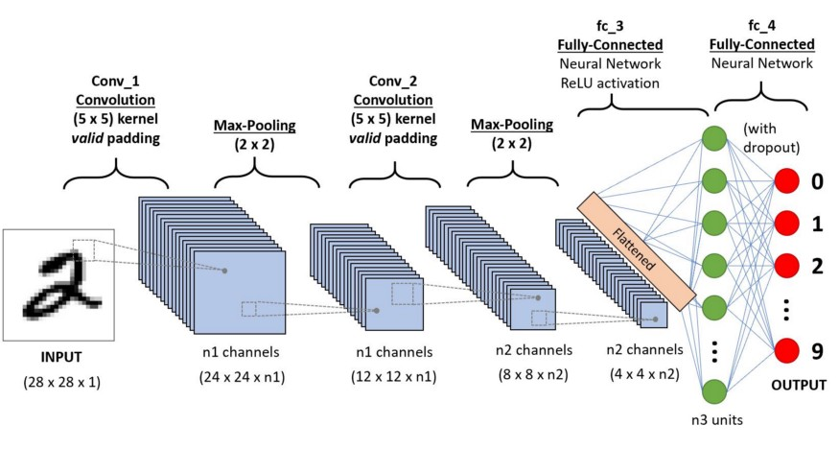

Yann LeCun, director of [Facebook’s AI Research Group](https://ai.facebook.com/research/), is the pioneer of convolutional neural networks. He built the first convolutional neural network called LeNet in 1988. LeNet was used for character recognition tasks like reading zip codes and digits. Have you ever wondered how facial recognition works on social media, or how object detection helps in building self-driving cars, or how disease detection is done using visual imagery in healthcare? It’s all possible thanks to convolutional neural networks (CNN). Here’s an example of convolutional neural networks that illustrates how they work:

Imagine there’s an image of a bird, and you want to identify whether it’s really a bird or some other object. The first thing you do is feed the pixels of the image in the form of arrays to the input layer of the [neural network](https://www.simplilearn.com/tutorials/deep-learning-tutorial/what-is-neural-network) (multi-layer networks used to classify things). The hidden layers carry out feature extraction by performing different calculations and manipulations. There are multiple hidden layers like the convolution layer, the ReLU layer, and pooling layer, that perform feature extraction from the image. Finally, there’s a fully connected layer that identifies the object in the image.

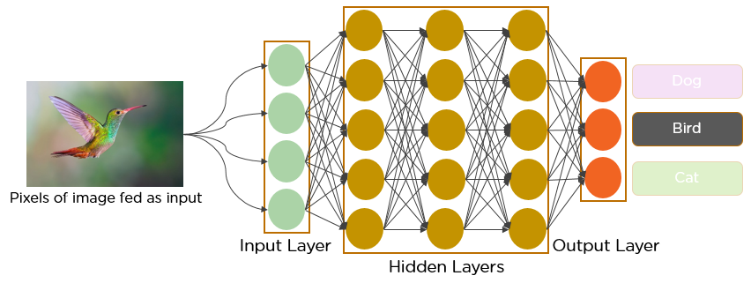

**What is Convolutional Neural Network?**

A convolutional neural network is a feed-forward neural network that is generally used to analyse visual images by processing data with grid-like topology. It’s also known as a ConvNet. A convolutional neural network is used to detect and classify objects in an image. Below is a [neural network](https://www.simplilearn.com/tutorials/deep-learning-tutorial/neural-network) that identifies two types of flowers: Orchid and Rose.

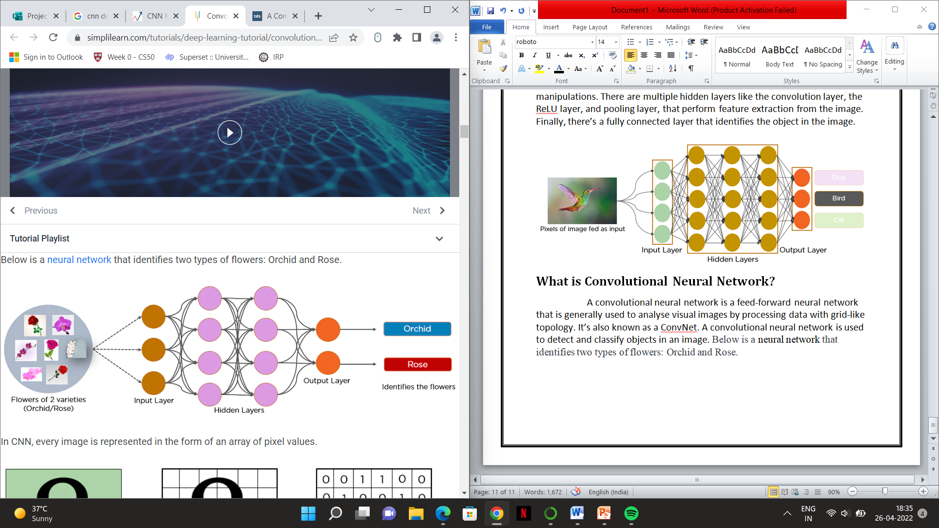

In CNN, every image is represented in the form of an array of pixel values.

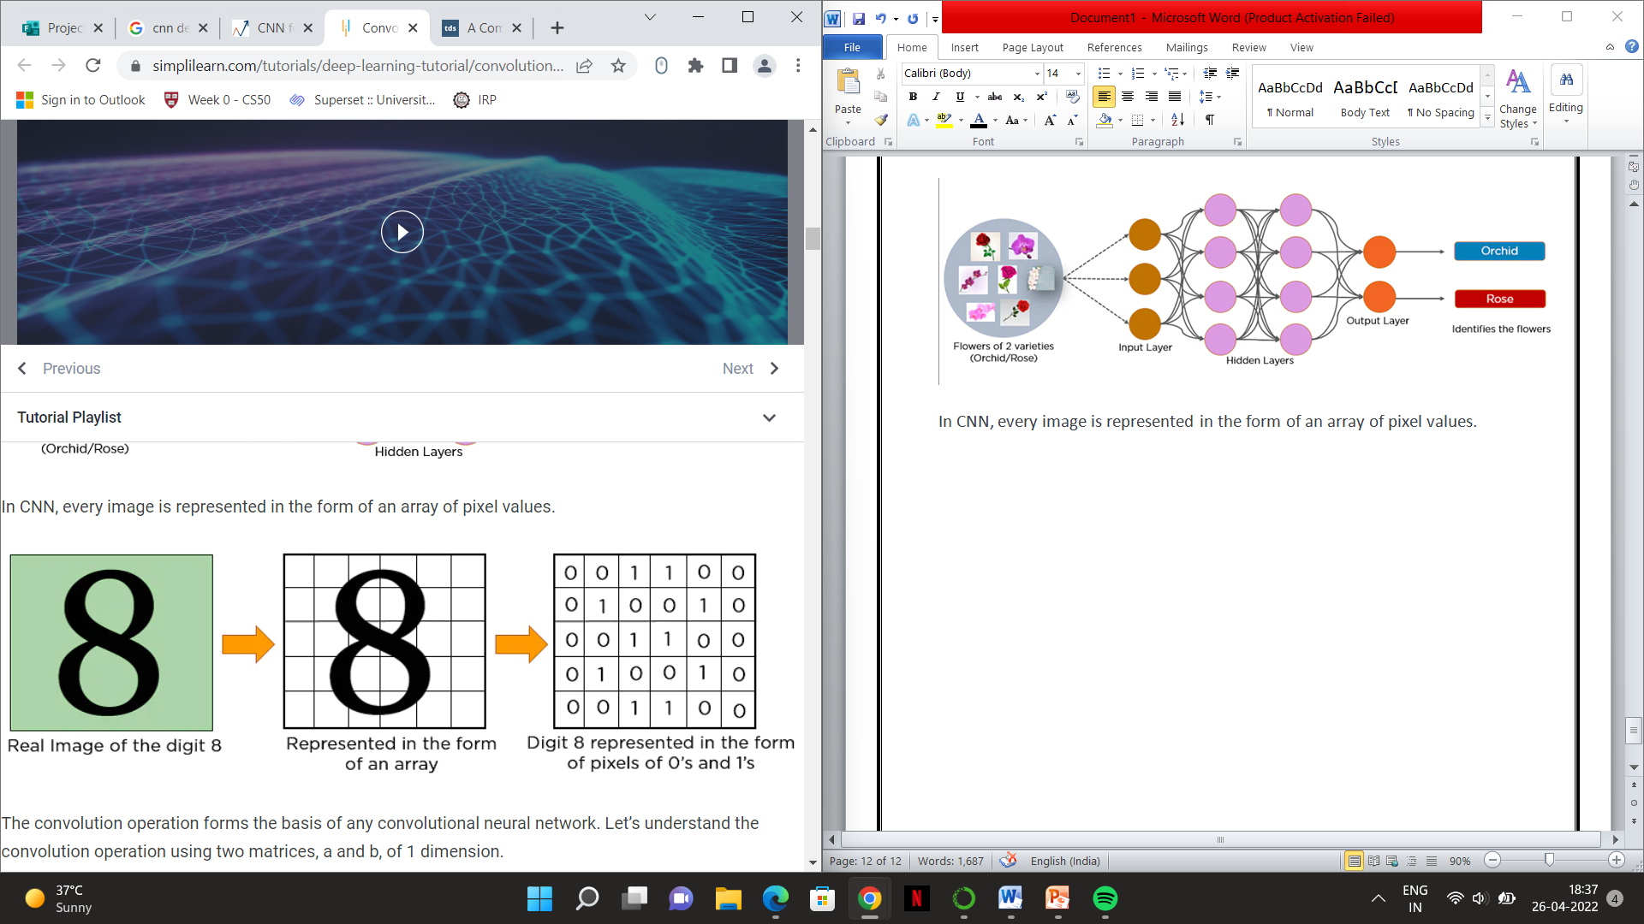

The convolution operation forms the basis of any convolutional neural network. Let’s understand the convolution operation using two matrices, a and b, of 1 dimension.

a = [5,3,7,5,9,7]

b = [1,2,3]

In convolution operation, the arrays are multiplied element-wise, and the product is summed to create a new array, which represents a*b.

The first three elements of the matrix a are multiplied with the elements of matrix b. The product is summed to get the result.

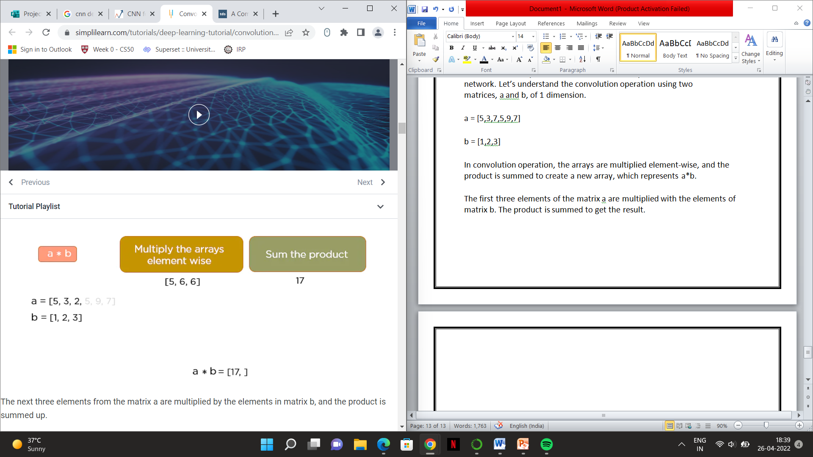

The next three elements from the matrix a are multiplied by the elements in matrix b, and the product is summed up.

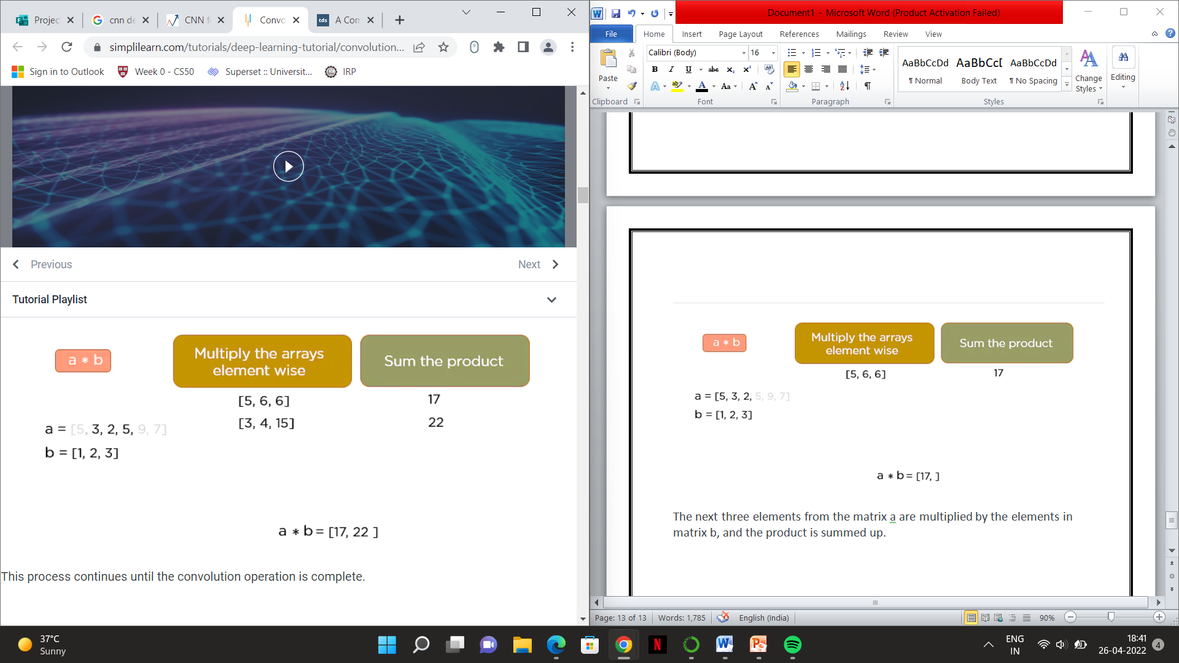

This process continues until the convolution operation is complete.

## How Does CNN Recognize Images?

Consider the following images:



The boxes that are colored represent a pixel value of 1, and 0 if not colored.

When you press backslash (\), the below image gets processed.



When you press forward-slash (/), the below image is processed:



Here is another example to depict how CNN recognizes an image:



As you can see from the above diagram, only those values are lit that have a value of 1.

**Layers in a Convolutional Neural Network**

A convolution neural network has multiple hidden layers that help in extracting information from an image. The four important layers in CNN are:

1. Convolution layer
2. ReLU layer
3. Pooling layer
4. Fully connected layer

### Convolution Layer

This is the first step in the process of extracting valuable features from an image. A convolution layer has several filters that perform the convolution operation. Every image is considered as a matrix of pixel values.

Consider the following 5x5 image whose pixel values are either 0 or 1. There’s also a filter matrix with a dimension of 3x3. Slide the filter matrix over the image and compute the dot product to get the convolved feature matrix.

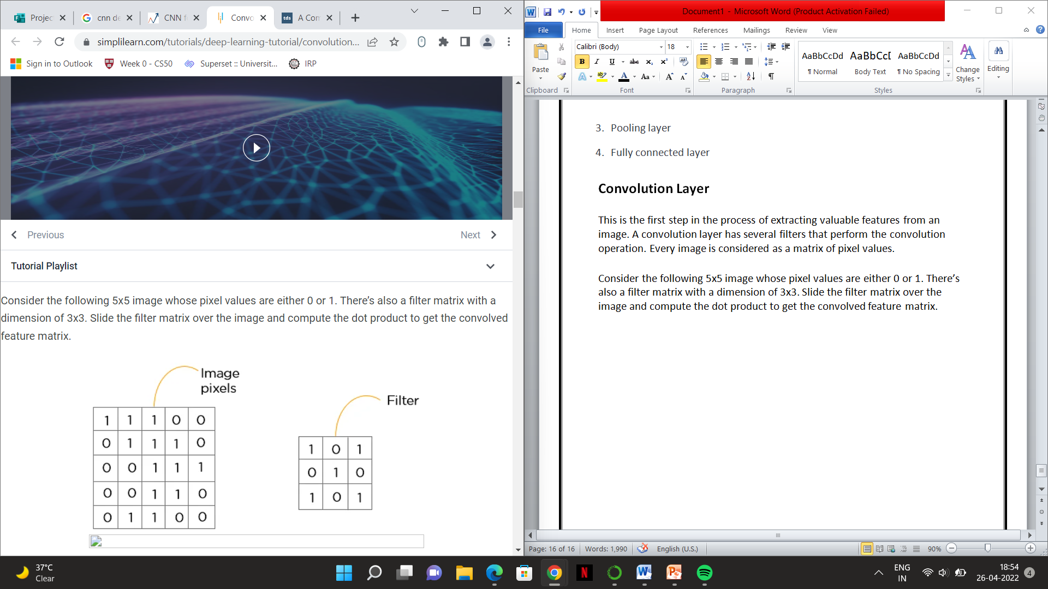

### ReLU layer

ReLU stands for the rectified linear unit. Once the feature maps are extracted, the next step is to move them to a ReLU layer. ReLU performs an element-wise operation and sets all the negative pixels to 0. It introduces non-linearity to the network, and the generated output is a rectified feature map. Below is the graph of a ReLU function:

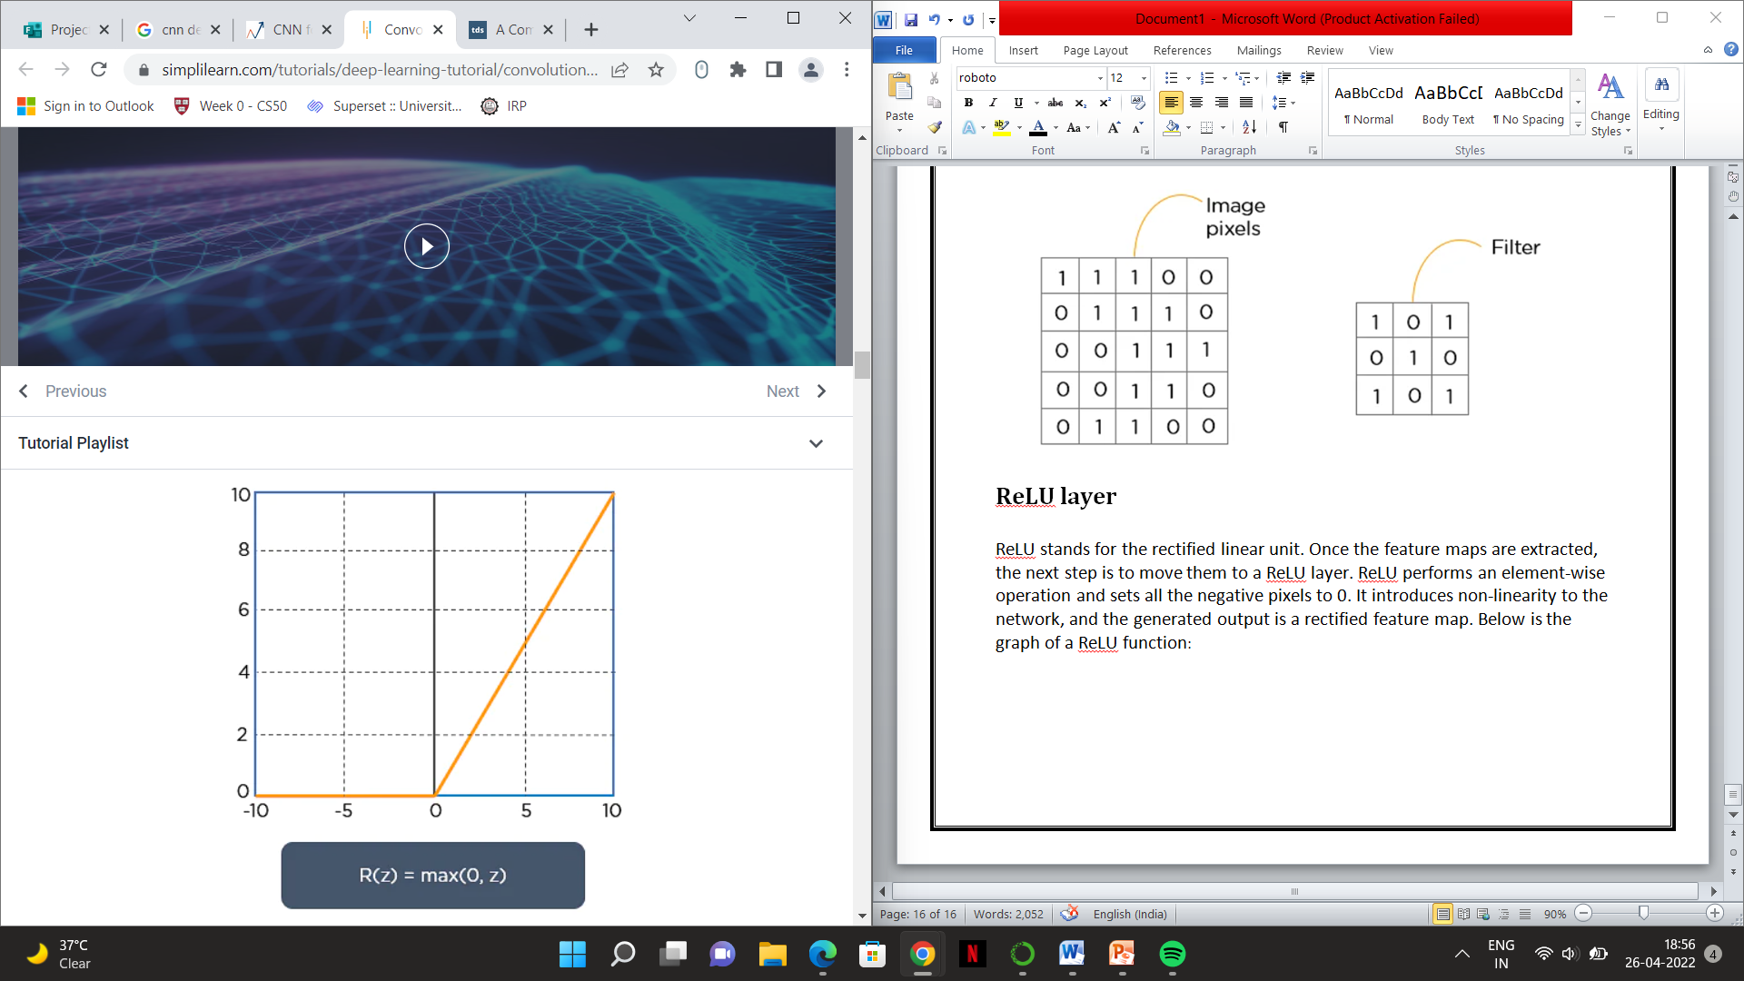

The original image is scanned with multiple convolutions and ReLU layers for locating the features.

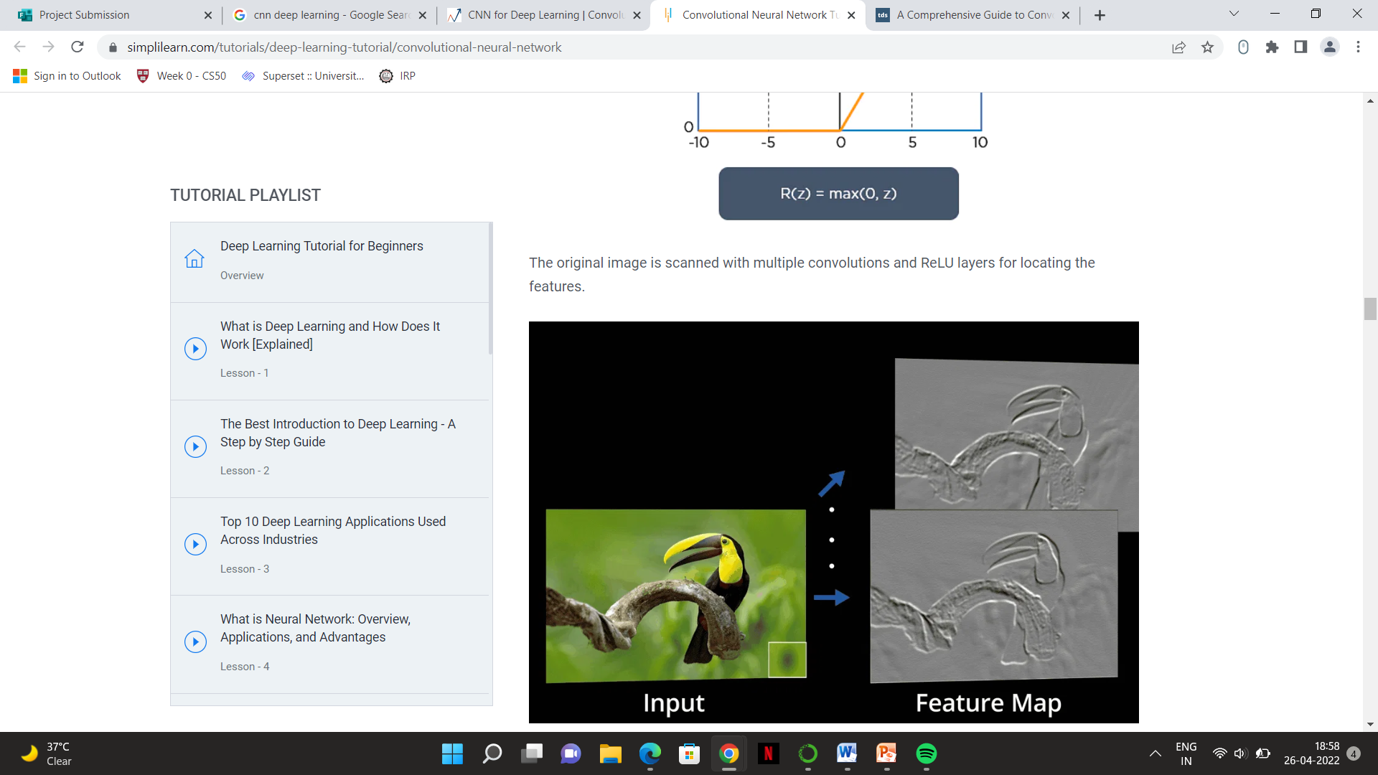

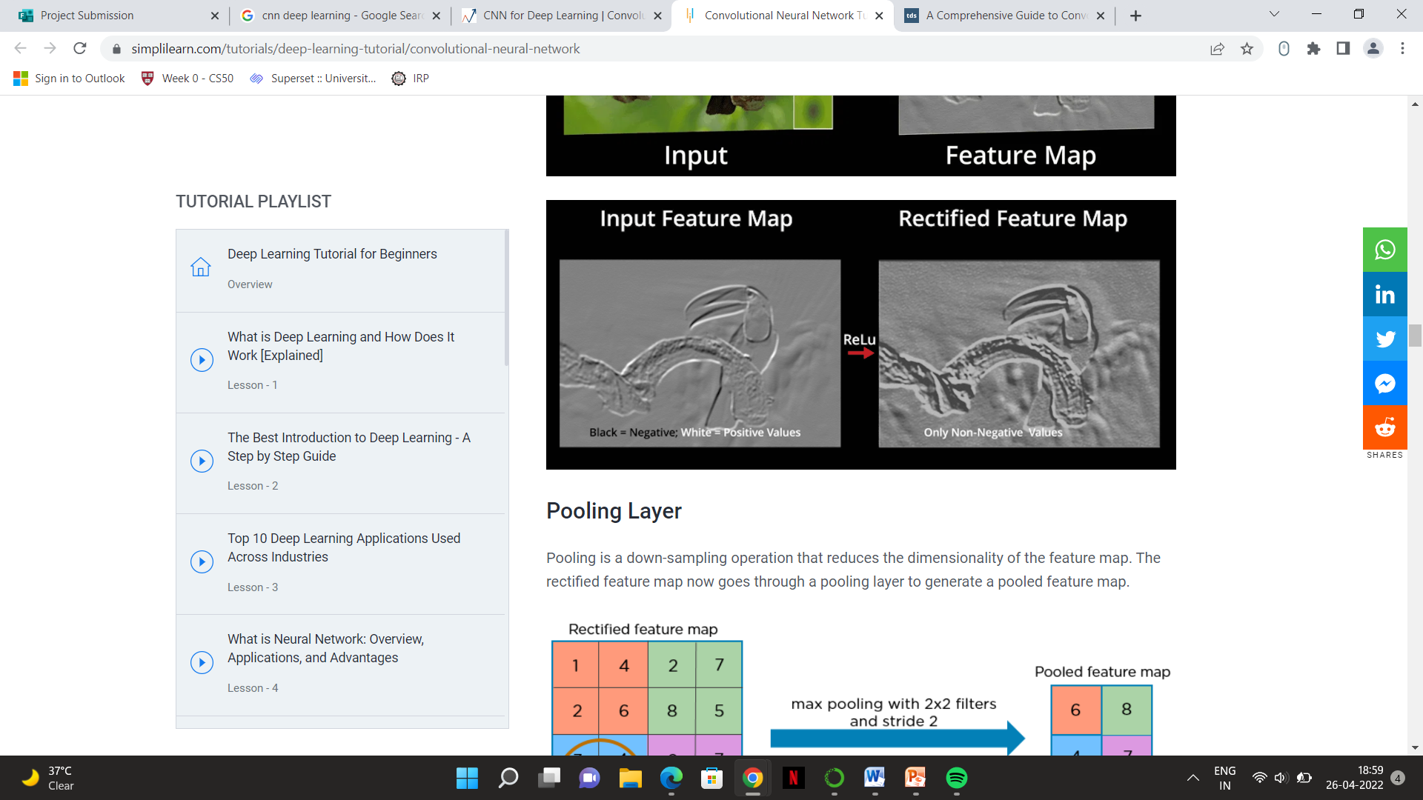

### Pooling Layer

Pooling is a down-sampling operation that reduces the dimensionality of the feature map. The rectified feature map now goes through a pooling layer to generate a pooled feature map.

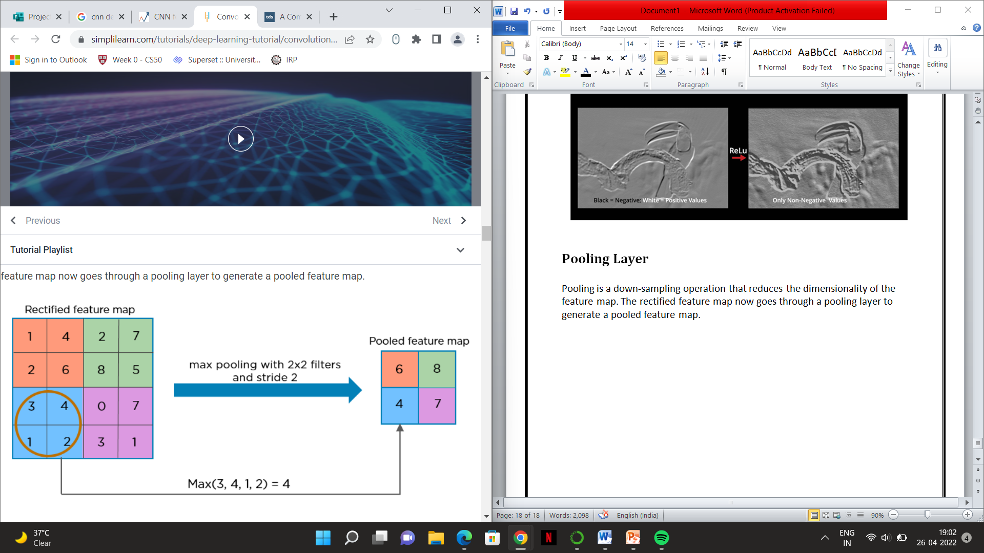

The pooling layer uses various filters to identify different parts of the image like edges, corners, body, feathers, eyes, and beak.

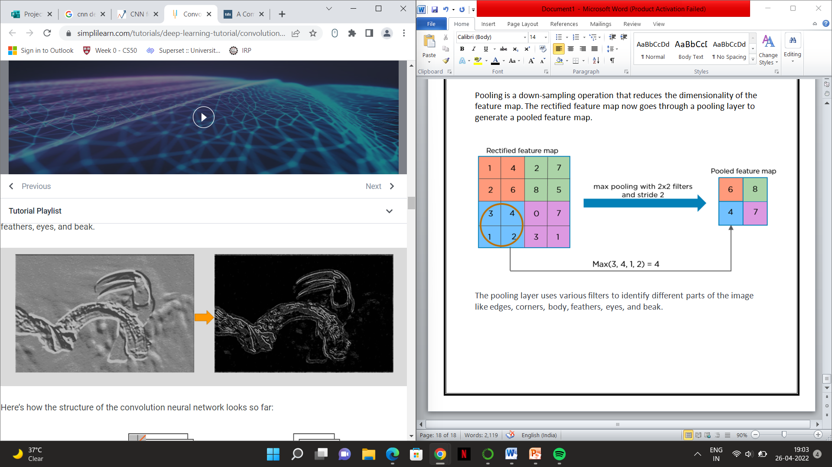

Here’s how the structure of the convolution neural network looks so far:

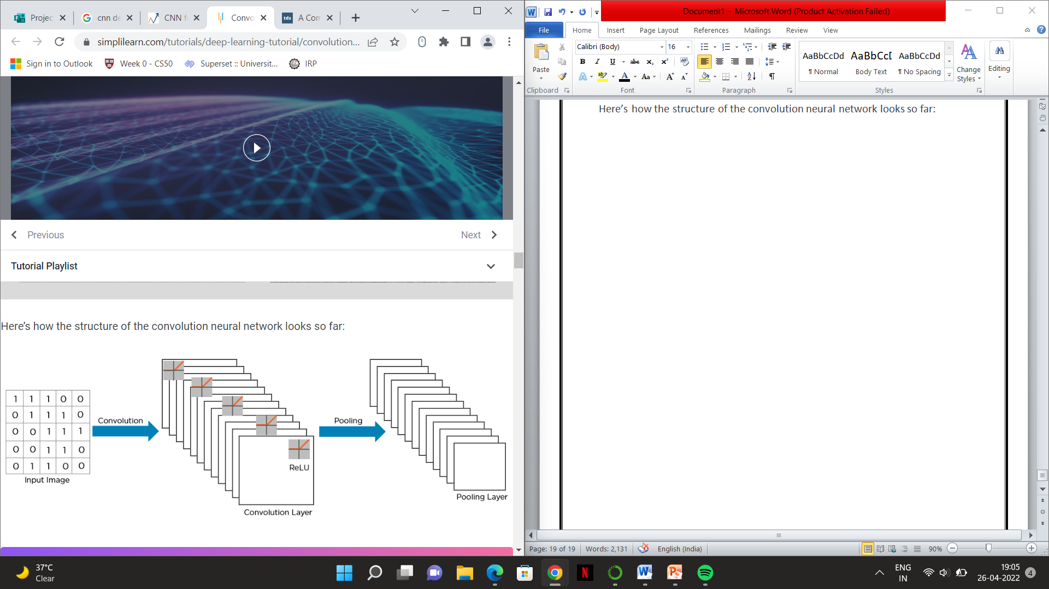

The next step in the process is called flattening. Flattening is used to convert all the resultant 2-Dimensional arrays from pooled feature maps into a single long continuous linear vector.

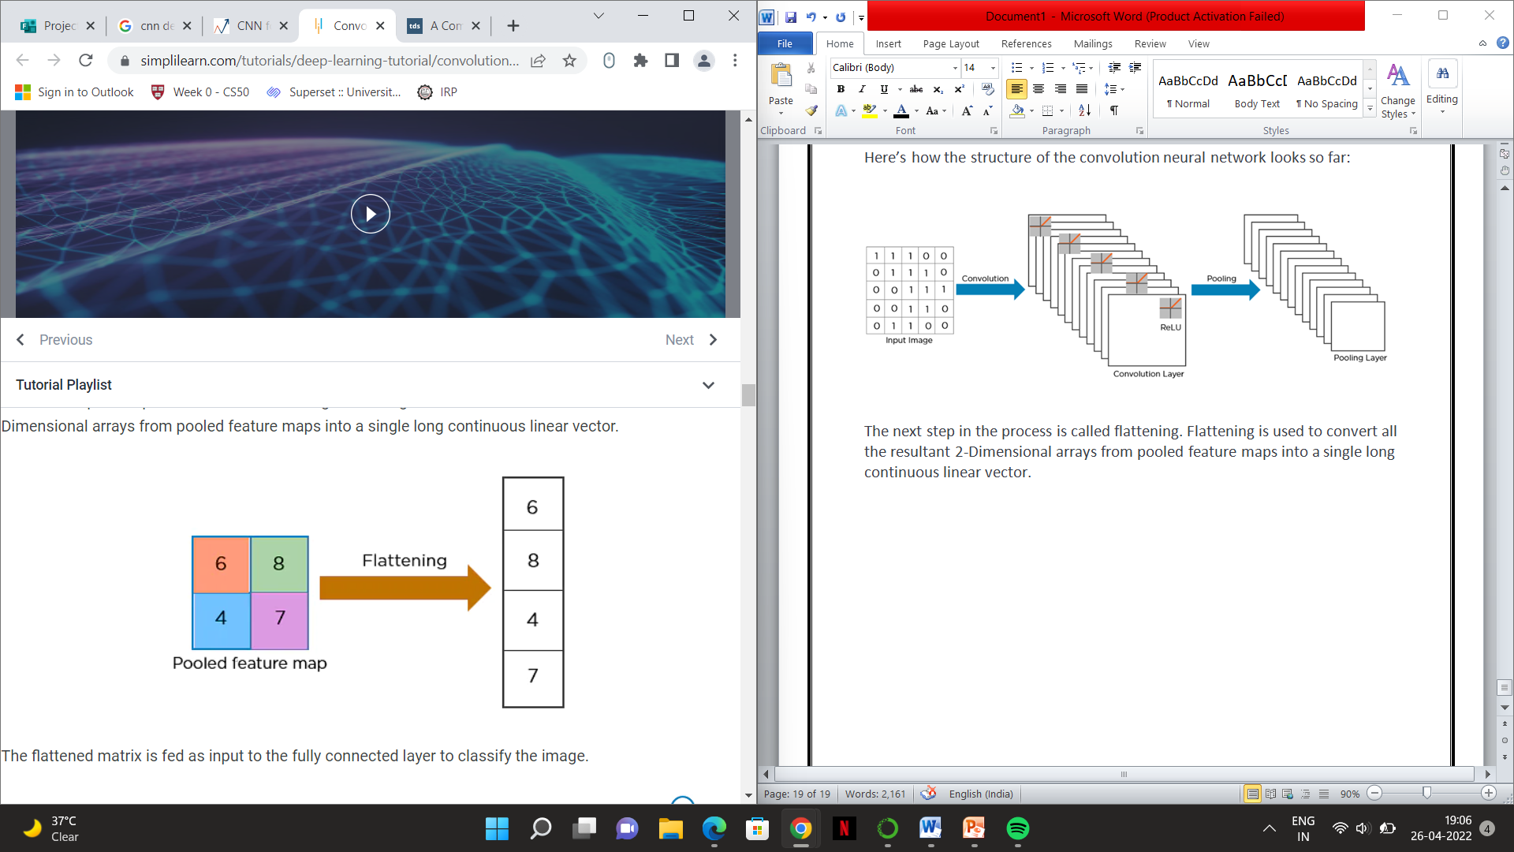

The flattened matrix is fed as input to the fully connected layer to classify the image.

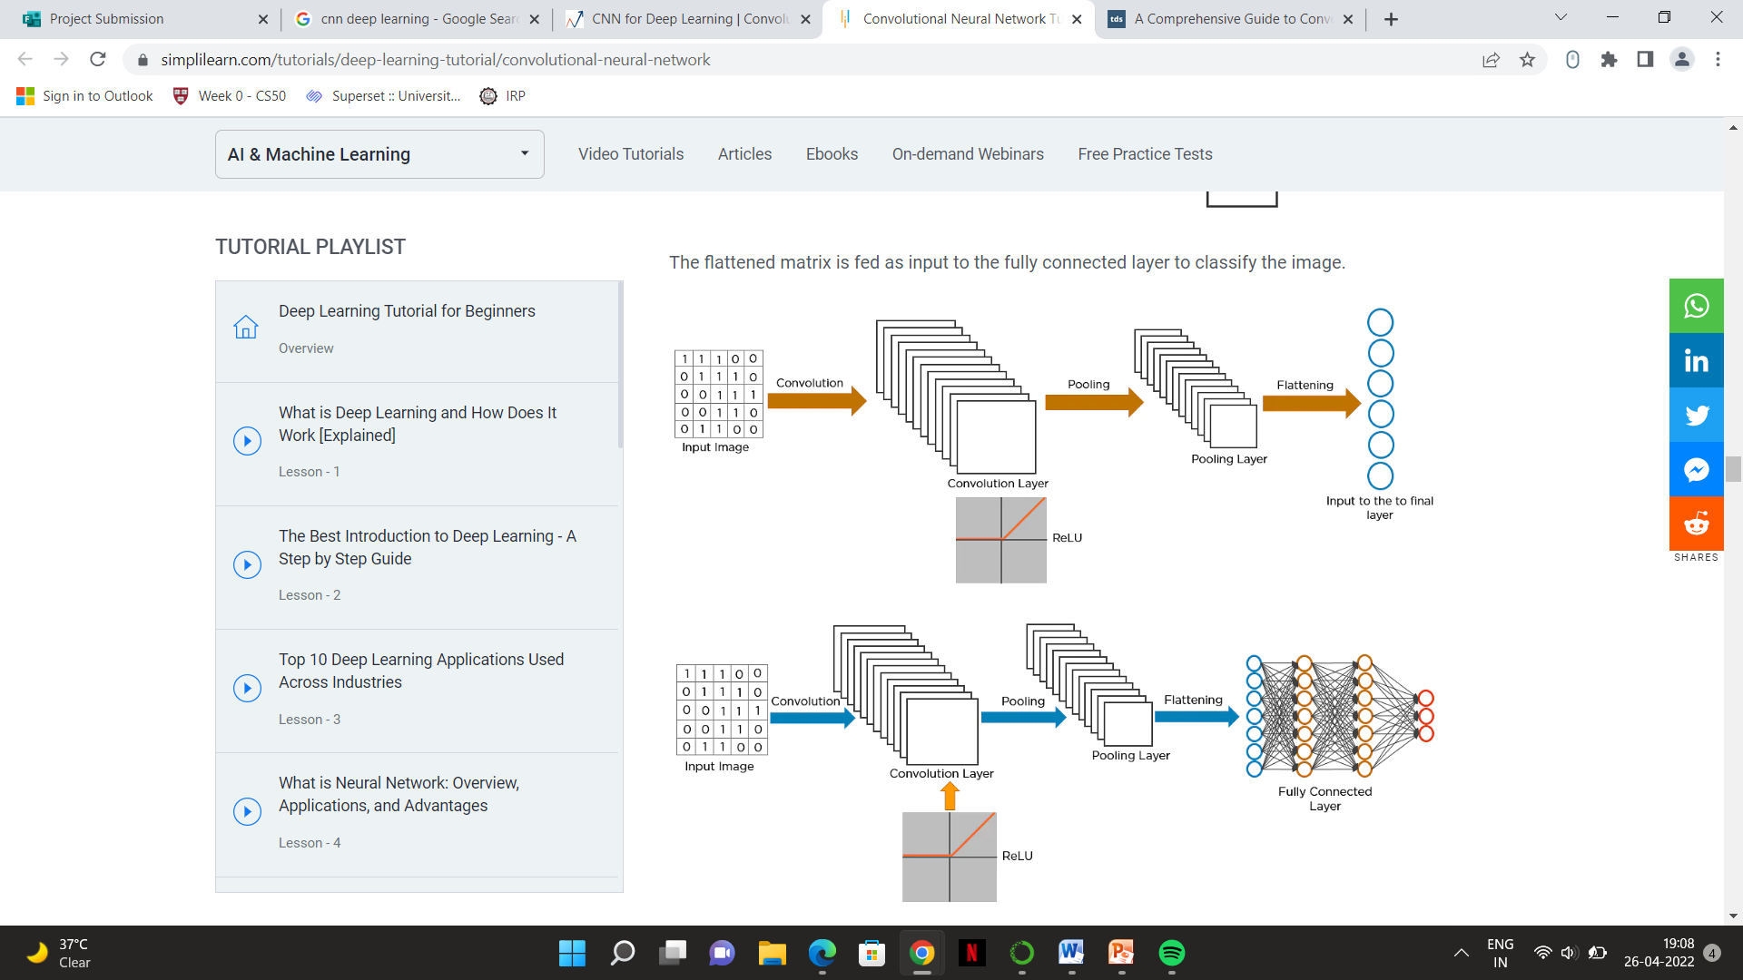

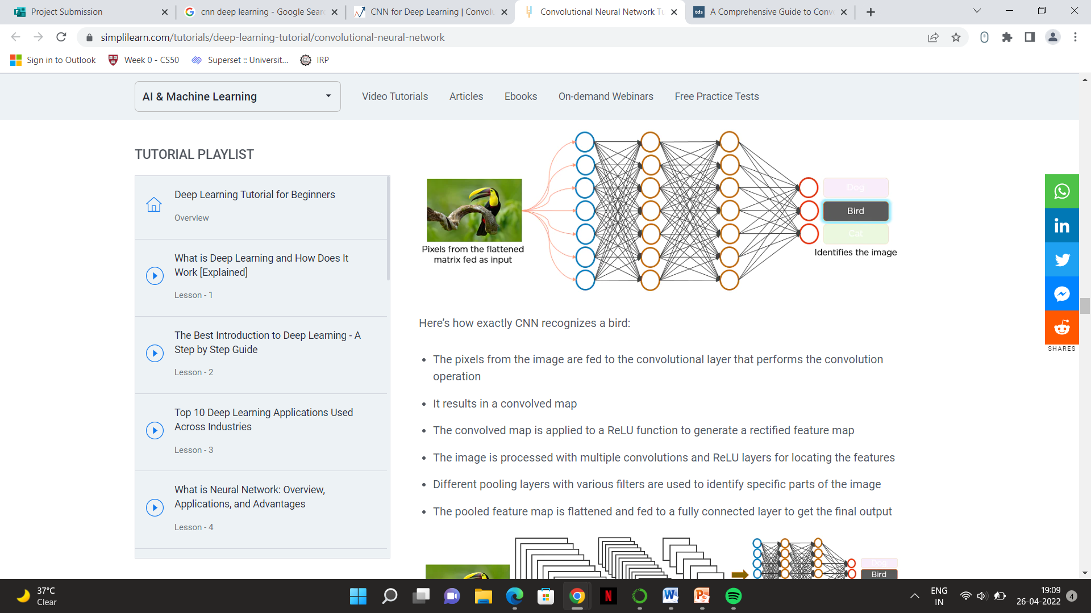Here’s how exactly CNN recognizes a bird:

* The pixels from the image are fed to the convolutional layer that performs the convolution operation
* It results in a convolved map
* The convolved map is applied to a ReLU function to generate a rectified feature map
* The image is processed with multiple convolutions and ReLU layers for locating the features
* Different pooling layers with various filters are used to identify specific parts of the image
* The pooled feature map is flattened and fed to a fully connected layer to get the final output



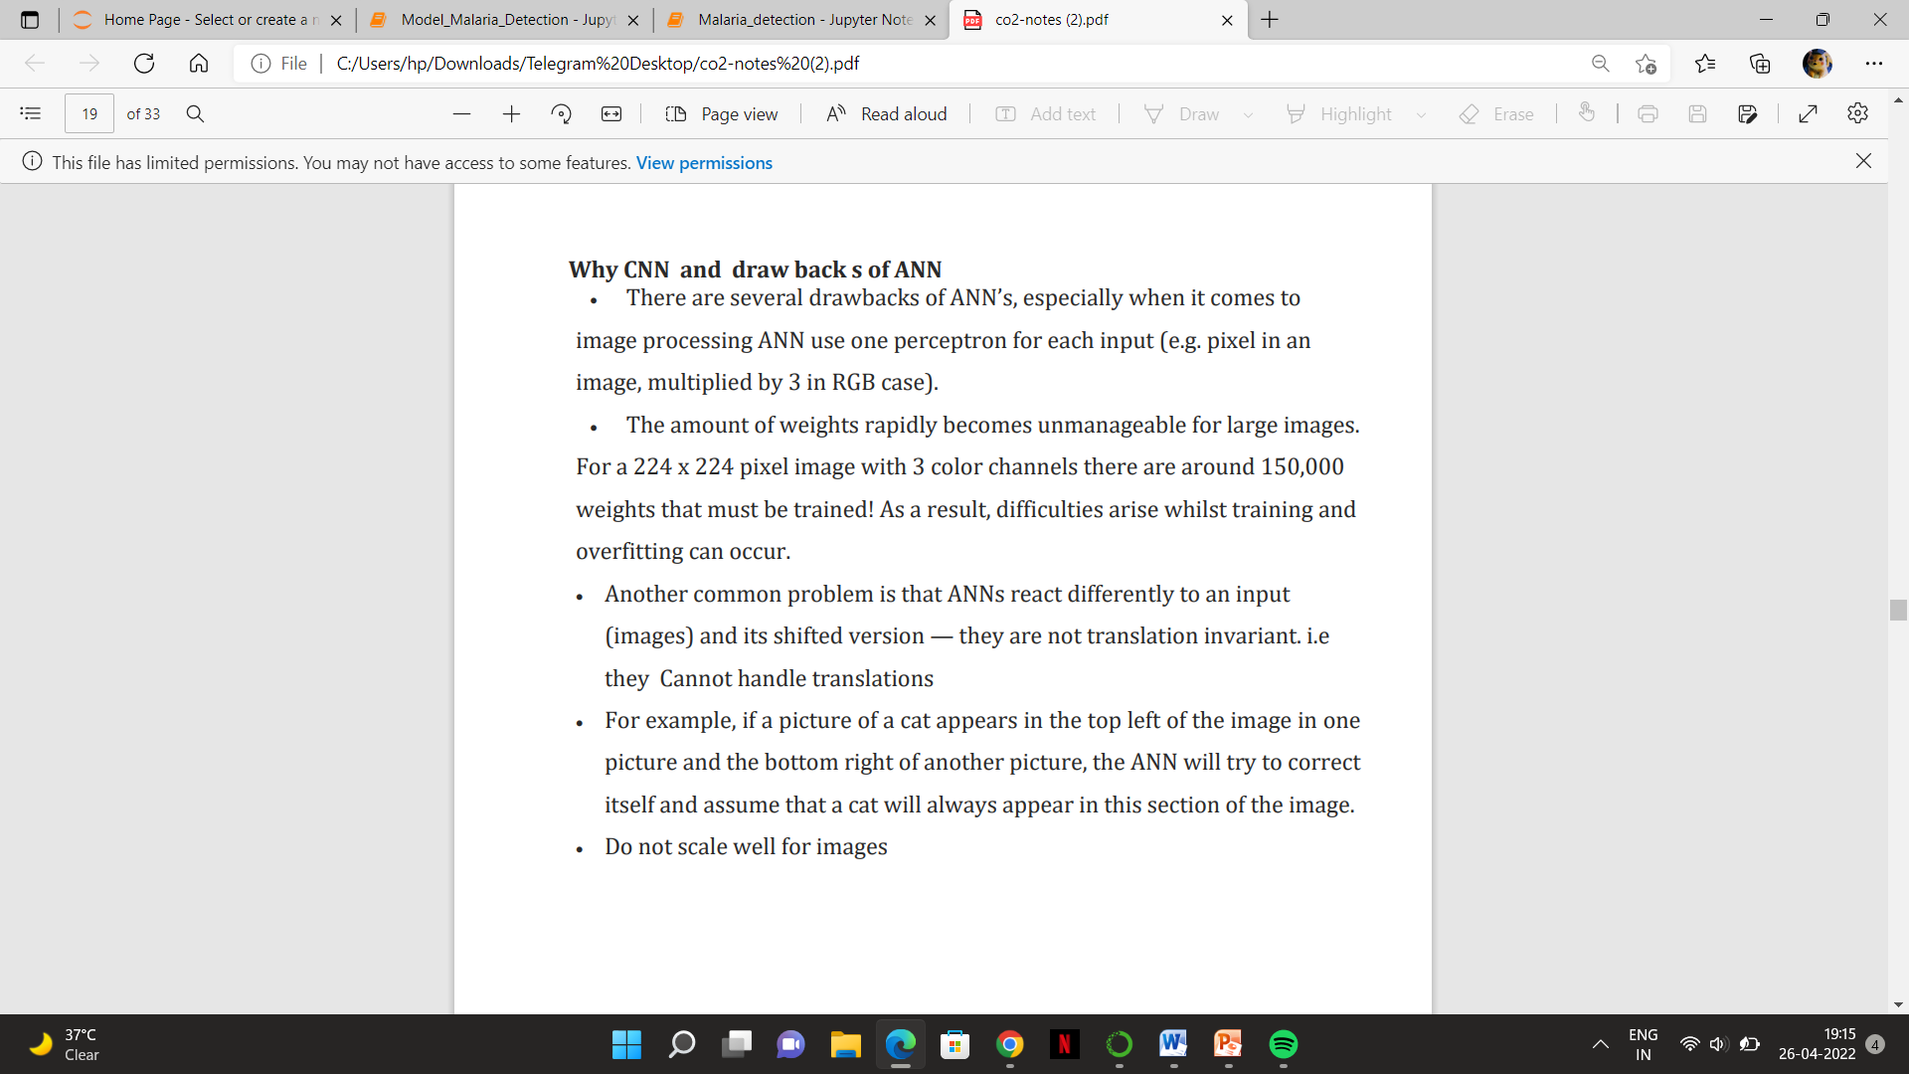

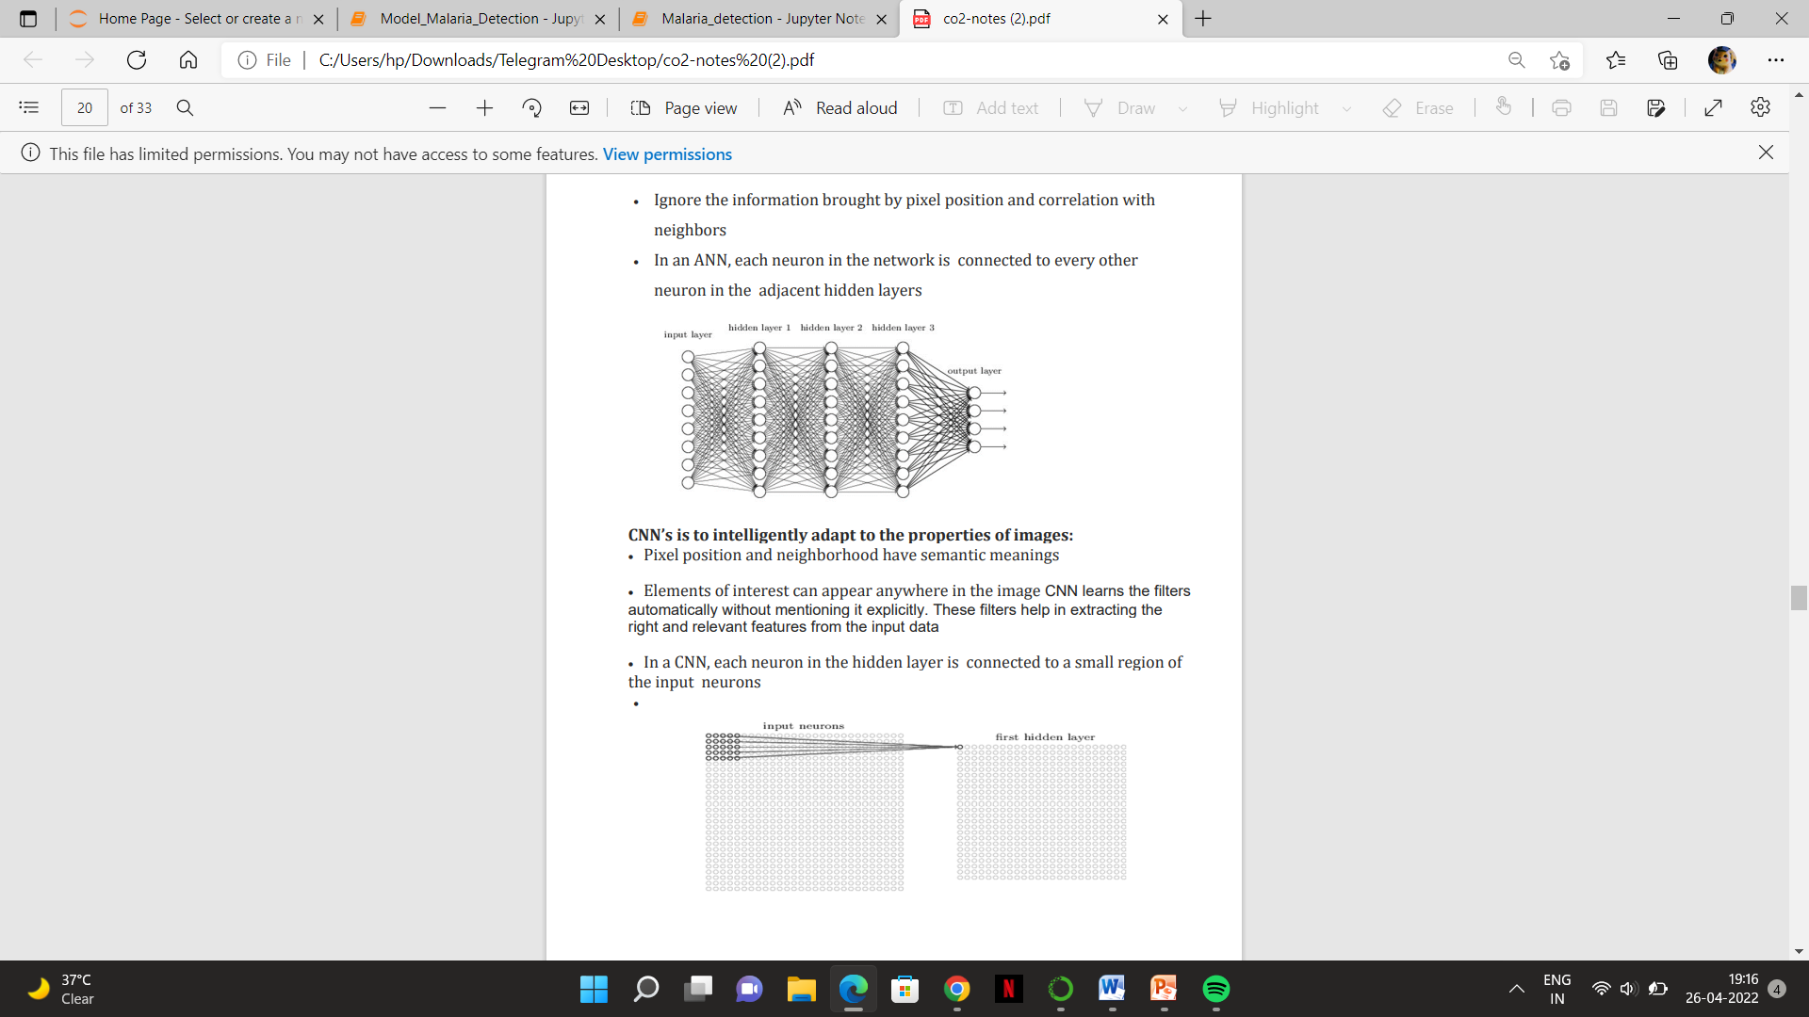There are various architectures of CNNs available which have been key in building algorithms which power and shall power AI as a whole in the foreseeable future. Some of them have been listed below:

1. LeNet
2. AlexNet
3. VGGNet
4. GoogLeNet
5. ResNet
6. ZFNet

**Implementation with Outputs**

# Step1. Loading the Data

import os

import random

# Imports for Managing Datasets

import numpy as np

import pandas as pd

# Imports for Data Visualization

import matplotlib.pyplot as plt

from matplotlib.image import imread

import seaborn as sns

# Directory for Parasitized cell images

parasitize_images_dir = '../Malaria_detection/cell_images/Parasitized'

# Directory for Uninfected cell images

uninfected_images_dir = '../Malaria_detection/cell_images/Uninfected'

# lets take a look at the number of images of parasitized cells

parasitize_images_dir = os.listdir(parasitize_images_dir)

len(parasitize_images_dir)

out: 13780

# lets take a look at the number of images of uninfected cells

uninfected_images_dir = os.listdir(uninfected_images_dir)

len(uninfected_images_dir)

out: 13780

# Step2. Exploratory Data Analysis(EDA)

## Parasitized Images:

# lets see a variety of parasitized cells

filenames= random.sample(os.listdir('../Malaria_detection/cell_images/Parasitized') , 25)

# here we will see 25 images of Parasitized cell images

plt.figure(figsize=(15, 15)) # figure size

for i in range(1, len(filenames)):

row = i

image = imread('../Malaria_detection/cell_images/Parasitized/' + filenames[i])

plt.subplot(5, 5, row)

plt.imshow(image)

plt.show()

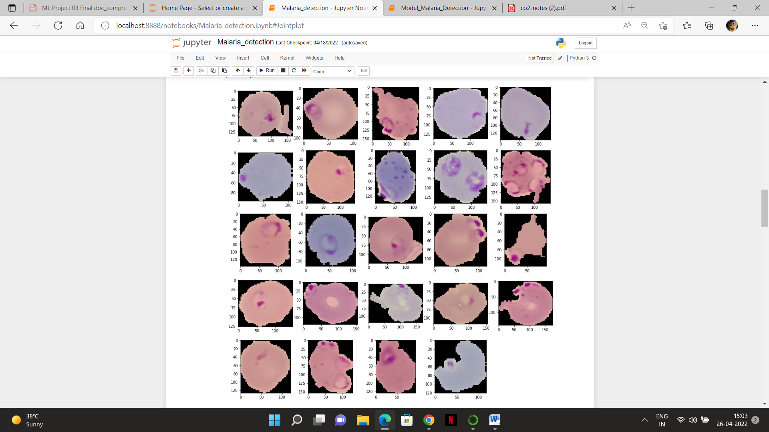

## Uninfected Images:

# lets see a variety of uninfected cells

filenames_= random.sample(os.listdir('../Malaria_detection/cell_images/Uninfected'), 26)

# here we will see 25 images of Uninfected cell images

plt.figure(figsize=(15, 15))

for i in range(1, len(filenames_)):

row = i

image = imread('../Malaria_detection/cell_images/Uninfected' + '/' + filenames_[i])

plt.subplot(5, 5, row)

plt.imshow(image)

plt.show()

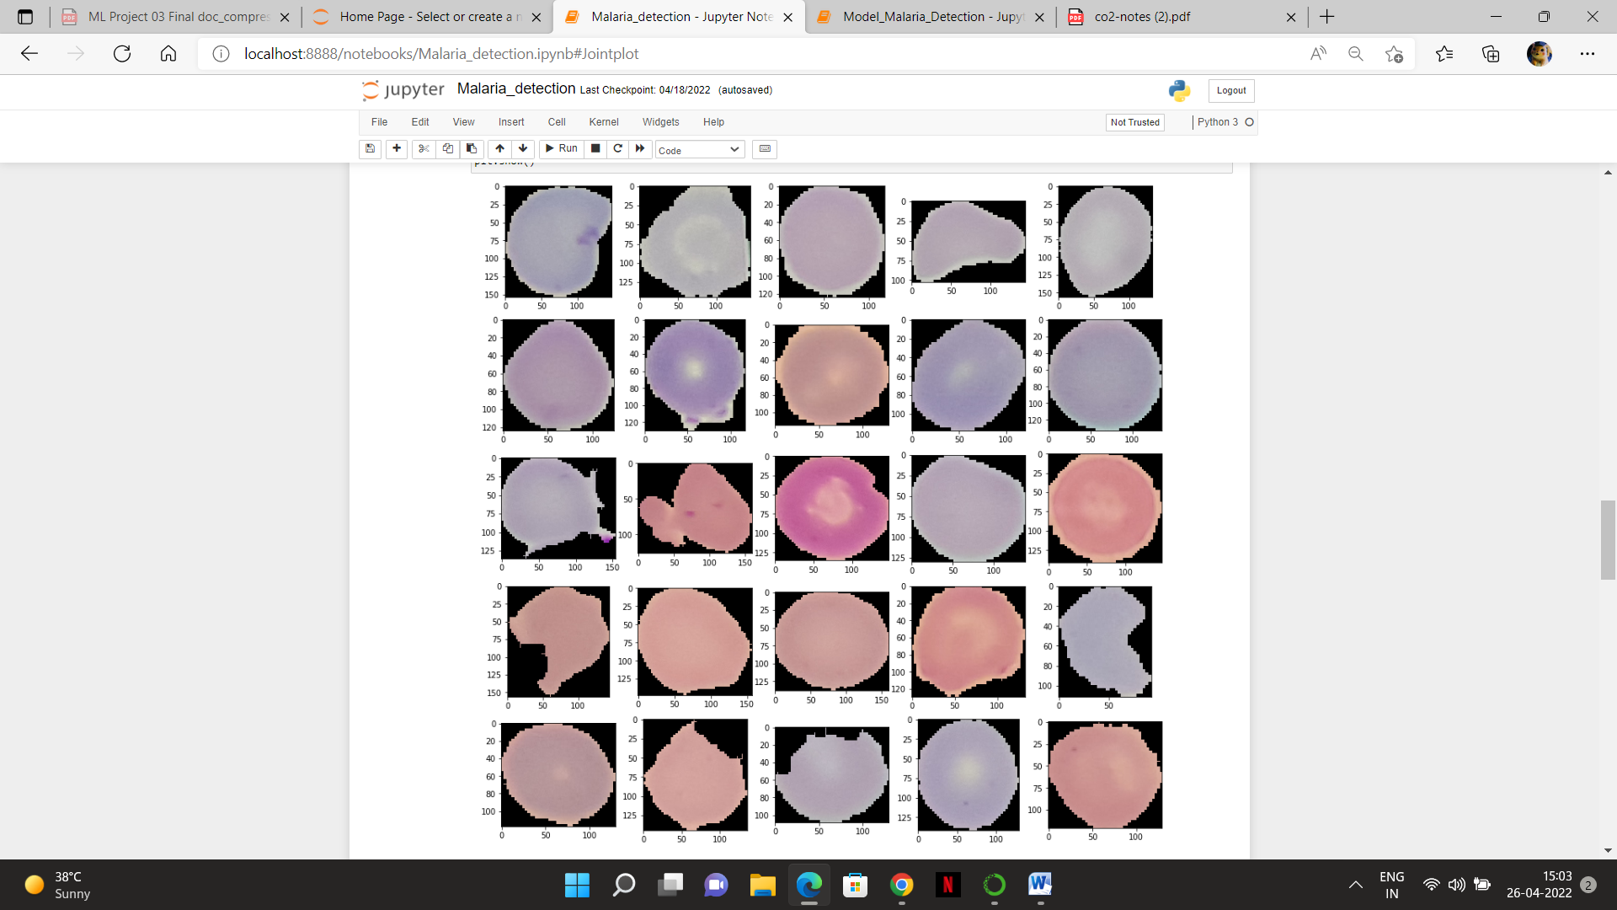

### Observations:

* One can clearly see the difference between the infected and uninfected. You can observe a small clot inside the cellular image for infected while for the uninfected the cellular image is clean without any clots.

### Let’s take a look at single cell

#### Parasitized Cell

# lets write the directory of a single Parasitized cell and take a look at it using imread

para_cell= '../Malaria_detection/cell_images/Parasitized/C100P61ThinF_IMG_20150918_144104_cell_163.png'

para_cell

plt.imshow(imread(para_cell))

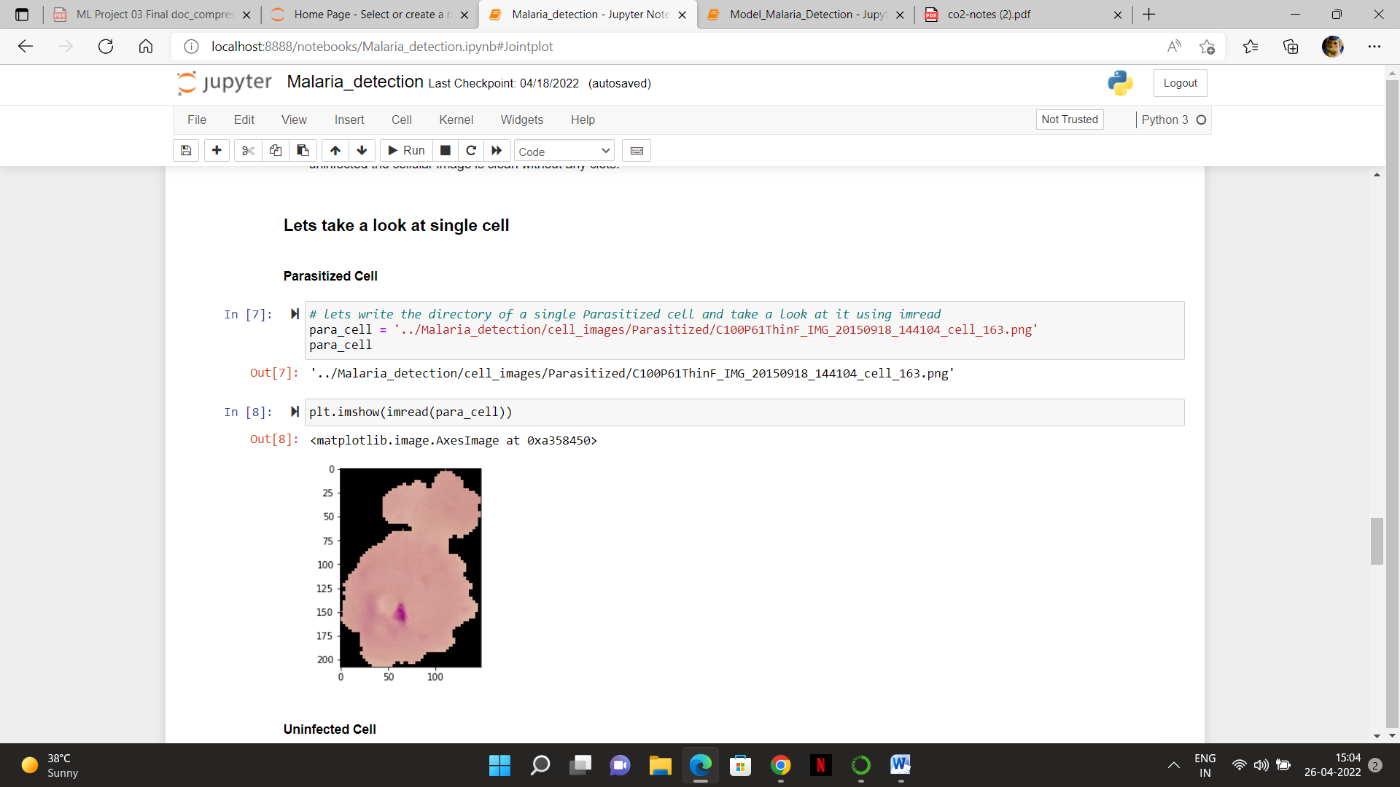

#### Uninfected Cell

#### # lets write the directory of a single Uninfected cell and take a look at it using imread

#### uninfected_cell = '../Malaria_detection/cell_images/Uninfected/C100P61ThinF_IMG_20150918_144104_cell_25.png'

#### uninfected_cell

plt.imshow(imread(uninfected_cell))

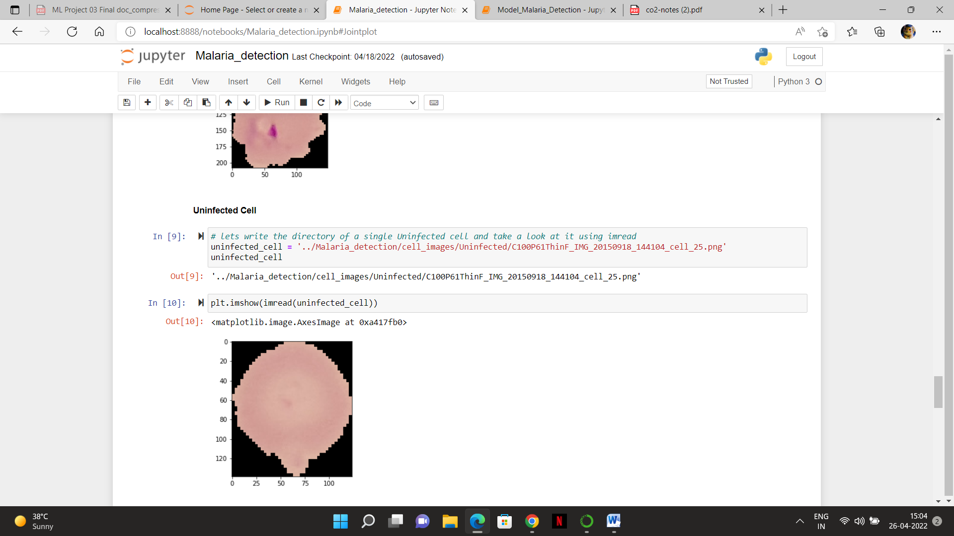

### Jointplot

#### Parasitized Cell Images

dim1_ = []

dim2_ = []

for image_filename in os.listdir('../Malaria_detection/cell_images/Parasitized'):

if 'Thumbs.db' not in image_filename:

img = imread('../Malaria_detection/cell_images/Parasitized/' + image_filename)

d1,d2,colors = img.shape

dim1_.append(d1)

dim2_.append(d2)

# 'thumbs.db' files are database files containing the small images displayed when you view a folder in Thumbnail view

# we will have to remove them

sns.jointplot(dim1_,dim2_)

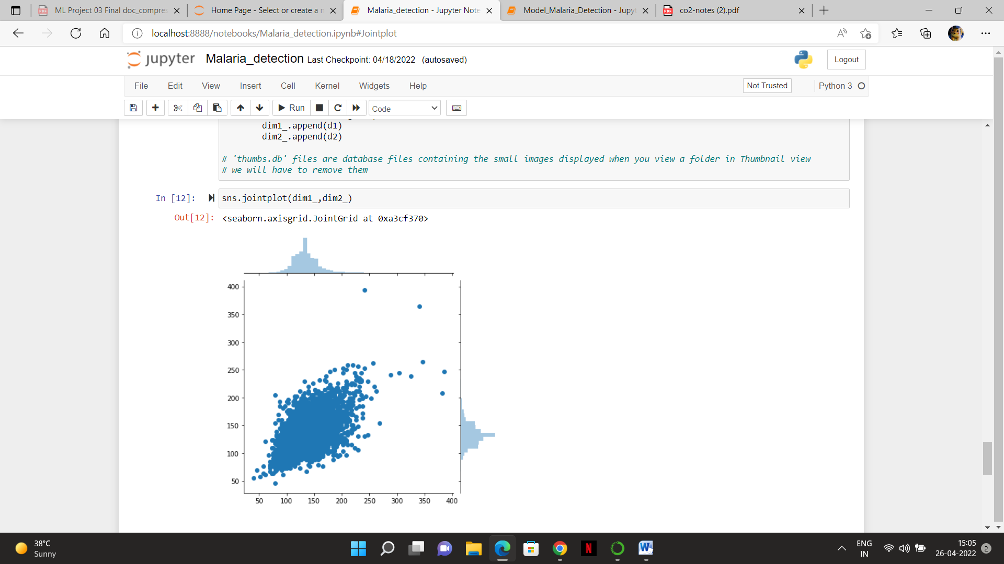

#### Uninfected Cell Images

dim1 = []

dim2 = []

for image_filename in os.listdir('../Malaria_detection/cell_images/Uninfected'):

if 'Thumbs.db' not in image_filename:

img = imread('../Malaria_detection/cell_images/Uninfected/' + image_filename)

d1,d2,colors = img.shape

dim1.append(d1)

dim2.append(d2)

sns.jointplot(dim1,dim2)

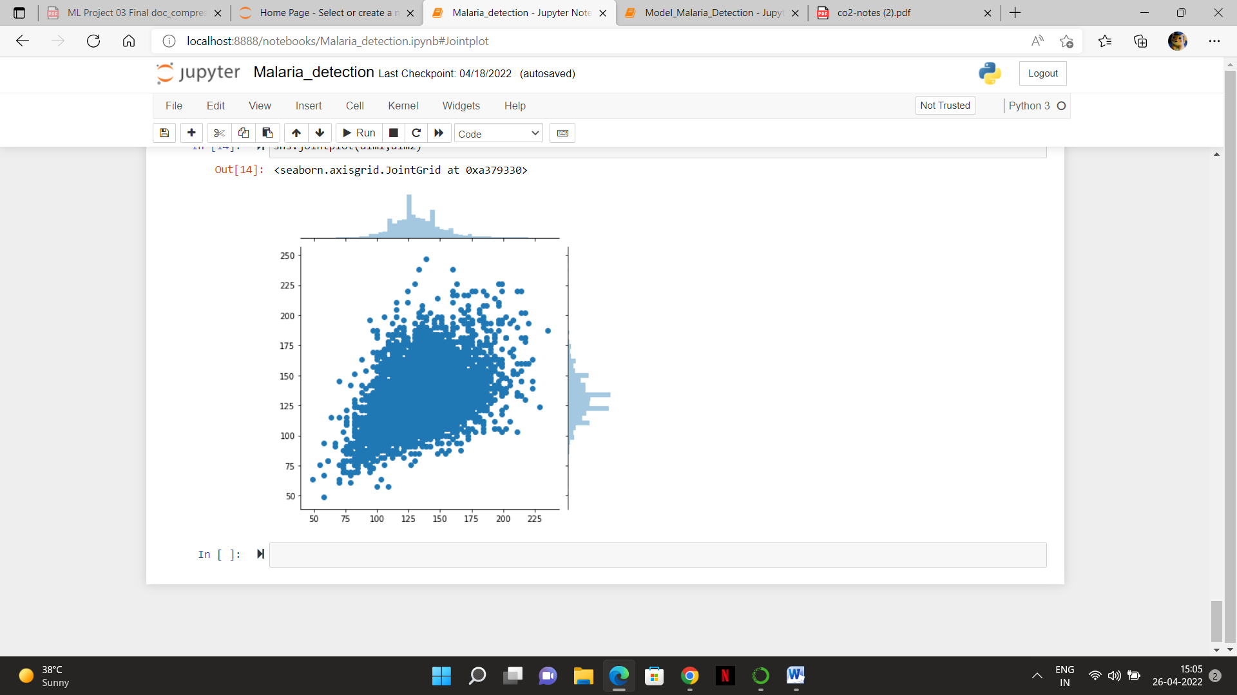

# Building Model for MALARIA DETECTION

### Lets take a look at how we are gonna make our model

#### Step 1: Loading and Splitting of the Dataset

* The first step is to load the data and scaling the images to binary 0 and 1 from Parasitized and Uninfected.
* Then we will resize the images to 50 x 50
* After that suffling of the images before train-test-split and converting the images to a single numpy array
* Splitting the data
* Converting the type of X_train and X_valid to float32
* Add then One Hot Encoding on y

#### Step 2: Building the CNN model

* The CNN model is one of the efficient nueral networks for images and performing classifications. We will use tf.keras to build the CNN model.
* We will build a Sequential CNN model.
* We will build a CNN Layer followed by MaxPooling layer which is later followed by BatchNormalisation to normalize the previous layer's output and implement the Dropout regularization. After that we will use Flatten to the outputs. Then the last layer that has function Softmax is the output layer.
* Finally we have to compile the CNN model. We will use optimizer called Adam then will apply the loss function as categorical_crossentropy and an evaluation metric as accuracy.
* Next step is to use the fit function, to train our convolutional neural network (CNN) with X_train and y_train. Lets set the total amounts of epochs as 25 epochs, which is essentially 25 cycles or iterations of the full dataset including a batch size of 120.

#### Step 3 : Predictions and Testing of the Model

* After this we will predict and do evaluation on the builded model.
* The last step will be to test our model on the HOLDOUT DATASET and making predictions.

### Importing Libraries

# importing the libraries for loading data and visualization

import os

import cv2

import pandas as pd

import numpy as np

import matplotlib.pyplot as plt

%matplotlib inline

from PIL import Image

import seaborn as sns

# import for train-test-split

from sklearn.model_selection import train_test_split

# import for One Hot Encoding

from keras.utils import to_categorical

# importing libraries for Model

import tensorflow as tf

from tensorflow import keras

from tensorflow.keras.models import Sequential

from tensorflow.keras.layers import Conv2D, MaxPooling2D

from tensorflow.keras.layers import Dense, Flatten, Dropout, BatchNormalization

# importing libraries for evaluating the model

from sklearn.metrics import accuracy_score

from sklearn.metrics import confusion_matrix

## Loading Data and Train-Test-Split:

# loading the data of images and setting their labels

data = []

labels = []

Parasitized = os.listdir("../input/cell-images-for-detecting-malaria/cell_images/Parasitized/")

for a in Parasitized:

try:

image = cv2.imread("../input/cell-images-for-detecting-malaria/cell_images/Parasitized/" + a)

image_from_array = Image.fromarray(image, 'RGB')

size_image = image_from_array.resize((50, 50))

data.append(np.array(size_image))

labels.append(0)

except AttributeError:

print("")

Uninfected = os.listdir("../input/cell-images-for-detecting-malaria/cell_images/Uninfected/")

for b in Uninfected:

try:

image = cv2.imread("../input/cell-images-for-detecting-malaria/cell_images/Uninfected/" + b)

image_from_array = Image.fromarray(image, 'RGB')

size_image = image_from_array.resize((50, 50))

data.append(np.array(size_image))

labels.append(1)

except AttributeError:

print("")

# Creating single numpy array of all the images and labels

data = np.array(data)

labels = np.array(labels)

print('Cells : {} and labels : {}'.format(data.shape , labels.shape))

# lets shuffle the data and labels before splitting them into training and testing sets

n = np.arange(data.shape[0])

np.random.shuffle(n)

data = data[n]

labels = labels[n]

output: Cells : (27558, 50, 50, 3) and labels : (27558,)

### Splitting the dataset into the Training set and Test set

X_train, X_valid, y_train, y_valid = train_test_split(data, labels, test_size = 0.2, random_state = 0)

print('Train data shape {} ,Test data shape {} '.format(X_train.shape, X_valid.shape))

X_train = X_train.astype('float32')

X_valid = X_valid.astype('float32')

# One Hot Encoding

y_train = to_categorical(y_train)

y_valid = to_categorical(y_valid)

## Building Model:

# Defining Model

classifier = Sequential()

# CNN layers

classifier.add(Conv2D(32, kernel_size=(3, 3), input_shape = (50, 50, 3), activation = 'relu'))

classifier.add(MaxPooling2D(pool_size = (2, 2)))

classifier.add(BatchNormalization(axis = -1))

classifier.add(Dropout(0.5)) # Dropout prevents overfitting

classifier.add(Conv2D(32, kernel_size=(3, 3), input_shape = (50, 50, 3), activation = 'relu'))

classifier.add(MaxPooling2D(pool_size = (2, 2)))

classifier.add(BatchNormalization(axis = -1))

classifier.add(Dropout(0.5))

classifier.add(Flatten())

classifier.add(Dense(units=128, activation='relu'))

classifier.add(BatchNormalization(axis = -1))

classifier.add(Dropout(0.5))

classifier.add(Dense(units=2, activation='softmax'))

classifier.compile(optimizer = 'adam', loss = 'categorical_crossentropy', metrics = ['accuracy'])

history = classifier.fit(X_train, y_train, batch_size=120, epochs=25, verbose=1, validation_data=(X_valid, y_valid))

output:

Epoch 1/25

184/184 [==============================] - 32s 172ms/step - loss: 0.7892 - accuracy: 0.6478 - val_loss: 2.0456 - val_accuracy: 0.5178

Epoch 2/25

184/184 [==============================] - 31s 167ms/step - loss: 0.4795 - accuracy: 0.7776 - val_loss: 1.7683 - val_accuracy: 0.6462

Epoch 3/25

184/184 [==============================] - 31s 169ms/step - loss: 0.3238 - accuracy: 0.8719 - val_loss: 1.8449 - val_accuracy: 0.6665

Epoch 4/25

184/184 [==============================] - 36s 195ms/step - loss: 0.2728 - accuracy: 0.8962 - val_loss: 0.6283 - val_accuracy: 0.8373

Epoch 5/25

184/184 [==============================] - 31s 171ms/step - loss: 0.2443 - accuracy: 0.9065 - val_loss: 0.4135 - val_accuracy: 0.8819

Epoch 6/25

184/184 [==============================] - 31s 167ms/step - loss: 0.2210 - accuracy: 0.9196 - val_loss: 0.4136 - val_accuracy: 0.8770

Epoch 7/25

184/184 [==============================] - 32s 174ms/step - loss: 0.2117 - accuracy: 0.9232 - val_loss: 0.3452 - val_accuracy: 0.8977

Epoch 8/25

184/184 [==============================] - 31s 167ms/step - loss: 0.1948 - accuracy: 0.9306 - val_loss: 0.3848 - val_accuracy: 0.8997

Epoch 9/25

184/184 [==============================] - 31s 170ms/step - loss: 0.1850 - accuracy: 0.9344 - val_loss: 0.2661 - val_accuracy: 0.9287

Epoch 10/25

184/184 [==============================] - 30s 164ms/step - loss: 0.1767 - accuracy: 0.9372 - val_loss: 0.3815 - val_accuracy: 0.8852

Epoch 11/25

184/184 [==============================] - 31s 166ms/step - loss: 0.1679 - accuracy: 0.9421 - val_loss: 0.2954 - val_accuracy: 0.9009

Epoch 12/25

184/184 [==============================] - 29s 160ms/step - loss: 0.1577 - accuracy: 0.9446 - val_loss: 0.2727 - val_accuracy: 0.9135

Epoch 13/25

184/184 [==============================] - 31s 168ms/step - loss: 0.1513 - accuracy: 0.9469 - val_loss: 0.2831 - val_accuracy: 0.9236

Epoch 14/25

184/184 [==============================] - 30s 164ms/step - loss: 0.1479 - accuracy: 0.9488 - val_loss: 0.2654 - val_accuracy: 0.9176

Epoch 15/25

184/184 [==============================] - 31s 168ms/step - loss: 0.1355 - accuracy: 0.9521 - val_loss: 0.1413 - val_accuracy: 0.9512

Epoch 16/25

184/184 [==============================] - 30s 164ms/step - loss: 0.1402 - accuracy: 0.9502 - val_loss: 0.1285 - val_accuracy: 0.9550

Epoch 17/25

184/184 [==============================] - 30s 165ms/step - loss: 0.1354 - accuracy: 0.9532 - val_loss: 0.1658 - val_accuracy: 0.9445

Epoch 18/25

184/184 [==============================] - 30s 163ms/step - loss: 0.1320 - accuracy: 0.9548 - val_loss: 0.1545 - val_accuracy: 0.9472

Epoch 19/25

184/184 [==============================] - 31s 167ms/step - loss: 0.1281 - accuracy: 0.9550 - val_loss: 0.1491 - val_accuracy: 0.9483

Epoch 20/25

184/184 [==============================] - 30s 163ms/step - loss: 0.1302 - accuracy: 0.9541 - val_loss: 0.2571 - val_accuracy: 0.8743

Epoch 21/25

184/184 [==============================] - 31s 166ms/step - loss: 0.1246 - accuracy: 0.9567 - val_loss: 0.2030 - val_accuracy: 0.9376

Epoch 22/25

184/184 [==============================] - 30s 164ms/step - loss: 0.1197 - accuracy: 0.9589 - val_loss: 0.1662 - val_accuracy: 0.9448

Epoch 23/25

184/184 [==============================] - 31s 168ms/step - loss: 0.1159 - accuracy: 0.9596 - val_loss: 0.1483 - val_accuracy: 0.9512

Epoch 24/25

184/184 [==============================] - 36s 196ms/step - loss: 0.1195 - accuracy: 0.9575 - val_loss: 0.2037 - val_accuracy: 0.9311

Epoch 25/25

184/184 [==============================] - 31s 166ms/step - loss: 0.1148 - accuracy: 0.9611 - val_loss: 0.1686 - val_accuracy: 0.9523

print("Test_Accuracy: {:.2f}%".format(classifier.evaluate(X_valid, y_valid)[1]*100))

output:

173/173 [==============================] - 2s 11ms/step - loss: 0.1686 - accuracy: 0.9523

Test_Accuracy: 95.23%

## "The Neural Network gave Accuracy of 95.23% "

* Summary of the Model

classifier.summary()

output:

Model: "sequential"

_________________________________________________________________

Layer (type) Output Shape Param #

=================================================================

conv2d (Conv2D) (None, 48, 48, 32) 896

_________________________________________________________________

max_pooling2d (MaxPooling2D) (None, 24, 24, 32) 0

_________________________________________________________________

batch_normalization (BatchNo (None, 24, 24, 32) 128

_________________________________________________________________

dropout (Dropout) (None, 24, 24, 32) 0

_________________________________________________________________

conv2d_1 (Conv2D) (None, 22, 22, 32) 9248

_________________________________________________________________

max_pooling2d_1 (MaxPooling2 (None, 11, 11, 32) 0

_________________________________________________________________

batch_normalization_1 (Batch (None, 11, 11, 32) 128

_________________________________________________________________

dropout_1 (Dropout) (None, 11, 11, 32) 0

_________________________________________________________________

flatten (Flatten) (None, 3872) 0

_________________________________________________________________

dense (Dense) (None, 128) 495744

_________________________________________________________________

batch_normalization_2 (Batch (None, 128) 512

_________________________________________________________________

dropout_2 (Dropout) (None, 128) 0

_________________________________________________________________

dense_1 (Dense) (None, 2) 258

=================================================================

Total params: 506,914

Trainable params: 506,530

Non-trainable params: 384

_________________________________________________________________

## Prediction, Evaluation and Testing of the Model

* Lets do our first prediction using predict and predict X_valid and store in y_pred variable

y_pred = classifier.predict(X_valid)

# Convert back to categorical values

y_pred = np.argmax(y_pred, axis=1)

y_valid = np.argmax(y_valid, axis=1)

print('Accuracy Score: ', accuracy_score(y_valid, y_pred))

output:Accuracy Score: 0.9522859216255443

* Evaluation of the CNN model by Plotting Confusion Matrix

# Plotting the Confusion Matrix

conf = confusion_matrix(y_valid, y_pred)

sns.heatmap(conf, annot=True)

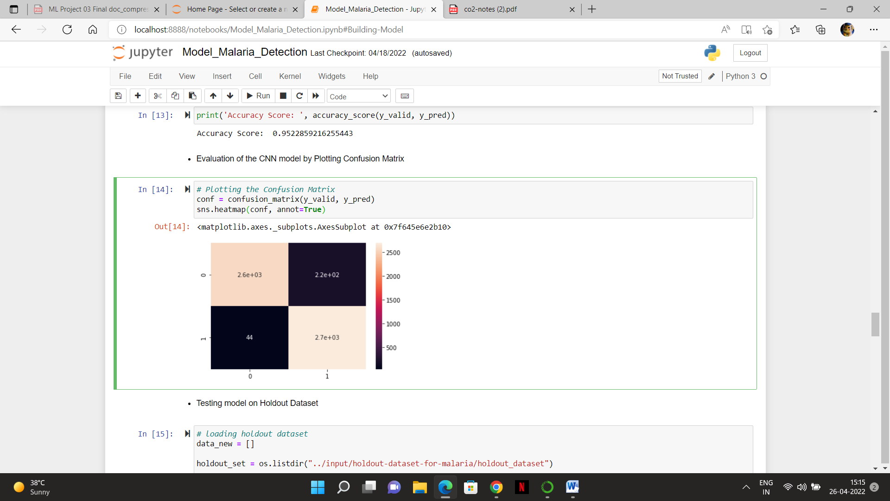

* Testing model on Holdout Dataset

# loading holdout dataset

data_new = []

holdout_set = os.listdir("../input/holdout-dataset-for-malaria/holdout_dataset")

for i in holdout_set:

try:

image = cv2.imread("../input/holdout-dataset-for-malaria/holdout_dataset/" + i)

image_from_array = Image.fromarray(image, 'RGB')

size_image = image_from_array.resize((50, 50))

data_new.append(np.array(size_image))

except AttributeError:

print("")

# Creating numpy array

data_new = np.array(data_new)

print(data_new.shape)

OUTPUT:(200, 50, 50, 3)

* Lets see now how our model predicts the Holdout dataset images
* Taking example of two images lets first take a look at the images and then predict them using our model and see how our model predicts the images

plt.imshow(data_new[10])

plt.imshow(data_new[199])

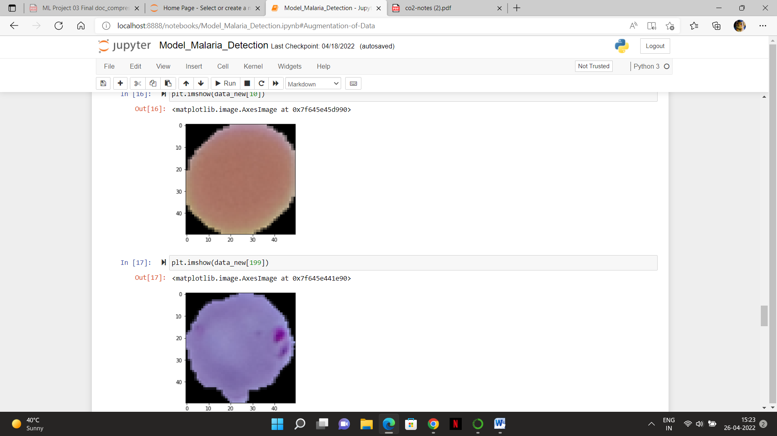

* Clearly the first one is Uninfected
* And second image is Parasitized
* Lets see what our model predicts now

data_new = data_new.astype('float32')

# prediction

pred = classifier.predict(data_new)

pred = np.argmax(pred, axis=1)

pred[10]

OUTPUT: 1

pred[199]

OUTPUT: 0

* The first prediction's output is 1, which means image is Uninfected
* Second prediction's output is 0, which means image is Parasitized
* So our model predictions are correct..

# Data Augmentation

### Augmentation of Data

from keras.preprocessing.image import ImageDataGenerator

train_generator = ImageDataGenerator(rescale = 1/255,

zoom_range = 0.3,

horizontal_flip = True,

rotation_range = 30)

test_generator = ImageDataGenerator(rescale = 1/255)

train_generator = train_generator.flow(np.array(X_train),

y_train,

batch_size = 120,

shuffle = False)

test_generator = test_generator.flow(np.array(X_valid),

y_valid,

batch_size = 120,

shuffle = False)

For the training data, we rescaled the pictures by dividing it by 255, zoomed pictures with a variety of 0.3, After that, flipped the pictures horizontally plus rotated them by 30. And for the remaining data, which is validating data, only rescale the pictures. The train_generator and test_generator methods are built with a batch size of 120.

### Calculating new accuracy

history = classifier.fit_generator(train_generator,

steps_per_epoch = len(X_train)/120,

epochs = 25,

shuffle = False)

print("Test_Accuracy(after augmentation): {:.2f}%".format(classifier.evaluate_generator(test_generator, steps = len(X_valid), verbose = 1)[1]*100))

Output:

Epoch 1/25

184/183 [==============================] - 39s 213ms/step - loss: 0.7904 - accuracy: 0.6249

Epoch 2/25

184/183 [==============================] - 39s 211ms/step - loss: 0.5544 - accuracy: 0.7242

Epoch 3/25

184/183 [==============================] - 37s 200ms/step - loss: 0.3866 - accuracy: 0.8398

Epoch 4/25

184/183 [==============================] - 38s 208ms/step - loss: 0.3146 - accuracy: 0.8783

Epoch 5/25

184/183 [==============================] - 42s 228ms/step - loss: 0.2782 - accuracy: 0.8960

Epoch 6/25

184/183 [==============================] - 37s 201ms/step - loss: 0.2613 - accuracy: 0.9058

Epoch 7/25

184/183 [==============================] - 38s 204ms/step - loss: 0.2488 - accuracy: 0.9104

Epoch 8/25

184/183 [==============================] - 38s 204ms/step - loss: 0.2359 - accuracy: 0.9163

Epoch 9/25

184/183 [==============================] - 37s 200ms/step - loss: 0.2229 - accuracy: 0.9204

Epoch 10/25

184/183 [==============================] - 37s 204ms/step - loss: 0.2104 - accuracy: 0.9282

Epoch 11/25

184/183 [==============================] - 37s 201ms/step - loss: 0.2049 - accuracy: 0.9296

Epoch 12/25

184/183 [==============================] - 37s 201ms/step - loss: 0.2038 - accuracy: 0.9296

Epoch 13/25

184/183 [==============================] - 38s 206ms/step - loss: 0.1954 - accuracy: 0.9337

Epoch 14/25

184/183 [==============================] - 37s 199ms/step - loss: 0.1911 - accuracy: 0.9356

Epoch 15/25

184/183 [==============================] - 37s 203ms/step - loss: 0.1867 - accuracy: 0.9370

Epoch 16/25

184/183 [==============================] - 37s 203ms/step - loss: 0.1856 - accuracy: 0.9380

Epoch 17/25

184/183 [==============================] - 37s 202ms/step - loss: 0.1850 - accuracy: 0.9391

Epoch 18/25

184/183 [==============================] - 37s 202ms/step - loss: 0.1814 - accuracy: 0.9407

Epoch 19/25

184/183 [==============================] - 37s 200ms/step - loss: 0.1780 - accuracy: 0.9418

Epoch 20/25

184/183 [==============================] - 37s 203ms/step - loss: 0.1755 - accuracy: 0.9412

Epoch 21/25

184/183 [==============================] - 43s 234ms/step - loss: 0.1751 - accuracy: 0.9419s -

Epoch 22/25

184/183 [==============================] - 36s 196ms/step - loss: 0.1765 - accuracy: 0.9434

Epoch 23/25

184/183 [==============================] - 37s 202ms/step - loss: 0.1734 - accuracy: 0.9428

Epoch 24/25

184/183 [==============================] - 38s 204ms/step - loss: 0.1719 - accuracy: 0.9435

Epoch 25/25

184/183 [==============================] - 36s 197ms/step - loss: 0.1719 - accuracy: 0.9442

46/5512 [..............................] - 2s 43ms/step - loss: 0.1596 - accuracy: 0.9490

Test_Accuracy(after augmentation): 94.90%

After that, we trained the classifier (the model) by utilizing the fit_generator method and measured that new accuracy.

### New Accuracy is approximately 95%

***Result***

Hence, we have identified the malaria infected and uninfected cells from the test and train Data using the Convolutional Neural Networks model in Deep learning by Implementing in Python Programming language.

The conventional and most standard way of diagnosing malaria is by visually examining blood smears via microscope for parasite- infected red blood cells under the microscope by qualified technicians. This method is inefficient and time consuming and the diagnosis depends on the experience and the knowledge of the person doing the examination. Automatic image recognition technologies based on image processing have been applied to malaria blood smears for diagnosis before. However, the practical performance has not been up to the mark so far. This gives us all the motivation to make malaria detection and diagnosis fast, easy and efficient.

Our main aim is to build a model that can detect cells from images of multiple cells in thin blood smear on standard microscope slides and classify them as either infected or uninfected with early and effective testing using image processing. And also perform classification on the infected cell image using deep learning.

***Conclusion***

* We can identify malaria infected cells from analyzing the microscopic images of the infected and uninfected cells as the disease presents itself in the cells on a cellular level. By doing this, we can increase the proper prediction of the disease and will be able to cure it without it becoming extremely serious and untreatable.
* Finally we can help doctors and patients by helping them understand the stage of the disease and what kind of treatments are required in order to cure malaria.
* We can also help them understand the recovery process every individual patient goes through as we analyze the severity of the disease.

Thank You